Universidade do Algarve
  - Faculdade de Ciências e Tecnologia
  - Licenciatura em Engenharia Informática

Redes de Computadores I

Laboratório 7
Wireshark – UDP

Realizado por: Diogo Carvalho nº 90247
PL: 2
Docente: Rui Filipe Rosa Paulo
Ano Letivo: 2025/2026

Relatório

- Select the first UDP segment in your trace. What is the packet number4 of this segment in the trace file? What type of application-layer payload or protocol message is being carried in this UDP segment? Look at the details of this packet in Wireshark. How many fields there are in the UDP header? (You shouldn’t look in the textbook! Answer these questions directly from what you observe in the packet trace.) What are the names of these fields?
R: O primeiro segmento UDP da captura é o pacote número 136. A mensagem transportada é uma mensagem DNS, mais concretamente uma Standard Query do tipo A para www.nyu.edu. O cabeçalho UDP tem 4 campos: Source Port, Destination Port, Length e Checksum.

- By consulting the displayed information in Wireshark’s packet content field for this packet (or by consulting the textbook), what is the length (in bytes) of each of the UDP header fields?
R: Cada campo do cabeçalho UDP tem 2 bytes. Assim, o campo Source Port tem 2 bytes, o campo Destination Port tem 2 bytes, o campo Length tem 2 bytes e o campo Checksum tem 2 bytes.

- The value in the Length field is the length of what? (You can consult the text for this answer). Verify your claim with your captured UDP packet.
R: O campo Length indica o tamanho total do segmento UDP, ou seja, o cabeçalho UDP mais o payload UDP. No pacote analisado, o valor é 37 bytes, o que confirma isso, porque são 8 bytes de cabeçalho e 29 bytes de payload.

- What is the maximum number of bytes that can be included in a UDP payload? (Hint: the answer to this question can be determined by your answer to 2. above)
R: O número máximo de bytes que podem ser incluídos no payload UDP é 65527 bytes.

- What is the largest possible source port number? (Hint: see the hint in 4.)
R: O maior valor possível para a source port é 65535.
- What is the protocol number for UDP? Give your answer in decimal notation. To answer this question, you’ll need to look into the Protocol field of the IP datagram containing this UDP segment (see Figure 4.13 in the text, and the discussion of IP header fields).
R: O número de protocolo do UDP é 17, em notação decimal.

- Examine the pair of UDP packets in which your host sends the first UDP packet and the second UDP packet is a reply to this first UDP packet. (Hint: for a second packet to be sent in response to a first packet, the sender of the first packet should be the destination of the second packet). What is the packet number5 of the first of these two UDP segments in the trace file? What is the value in the source port field in this UDP segment? What is the value in the destination port field in this UDP segment? What is the packet number6 of the second of these two UDP segments in the trace file? What is the value in the source port field in this second UDP segment? What is the value in the destination port field in this second UDP segment? Describe the relationship between the port numbers in the two packets.

R: O primeiro pacote deste par é o pacote número 136. Nesse pacote, a Source Port é 62178 e a Destination Port é 53. O segundo pacote é o pacote número 137. Nesse pacote, a Source Port é 53 e a Destination Port é 62178. A relação entre os números de porta é que, na resposta, as portas aparecem invertidas em relação ao pedido.

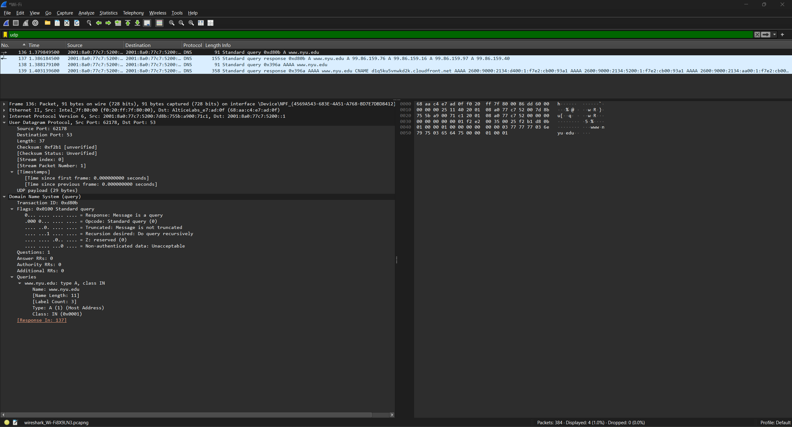
Query

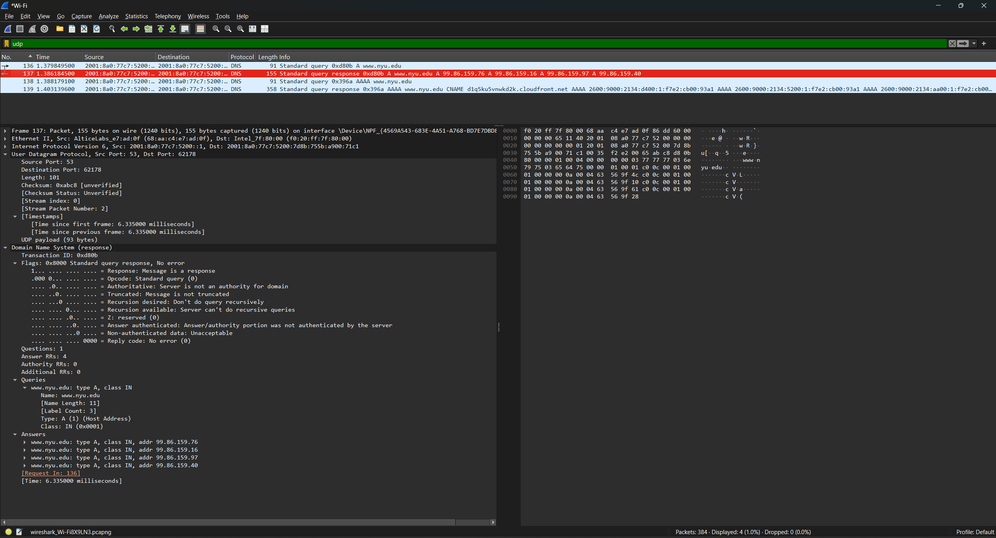
Resposta

